|  |  |
| --- | --- |
| USE CASE SPECIFICATION | |
| Use Case Name | Register/Sign-up Event |
| Brief Description | This use case enables the user to register or sign-up for an event that they are keen to attend. The user must be successfully logged into the CMP before register or signing up for an event. |
| Actors | |
| Primary Actor/s | Start-up Founder, Alumni |
| Secondary Actor/s | Admin |
| Flow of Events | |
| Main Flow (MF) | |
|  | DISPLAY EVENT  The use case begins with the system displaying all the events to the user. |
|  | SELECT EVENTS.  The user selects an event that they are interested to attend. |
|  | DISPLAY EVENT DETAILS.  The system will display the events details such as speaker, topics covered, objectives and timing. |
|  | ENTER PERSONAL INFORMATION.  User provide their personal information to sign up/ register for the events. |
|  | SIGNUP/ REGISTER SUCESSFUL.  The system will display a confirmation message on the screen to confirm their registration. The use case ends. |
| Alternate Flows (AF) | |
|  | SEARCH EVENT  At MF 4.1.1, the user can key in keywords to search for an event. The systems display the search result and the use case resumes at MF 4.1.2. |
|  | INCORRECT PERSONAL INFORMATION  At MF 4.1.4, the system checked that the user information is invalid. The system displays an error message and the use case resumes at MF 4.1.1. |
|  | ERROR DISPLAYING EVENTS  At MF 4.1.1, the system fails to display all the events from the CMP. An error message is displayed, and the use case ends. |
|  | CANCEL AN EVENT  At MF 4.1.4, the user decided to cancel the event by clicking on the cancel icon. A pop-up message will be displayed to confirm cancellation, and the use case ends. |

***STEP 1: Extract Nouns from use case specification***

|  |  |  |  |
| --- | --- | --- | --- |
| Nouns | Reject/Accept | reason to Reject | Type of class |
| System | Accept |  | Control (system name is ‘CMP’) |
| Screen | Accept |  | Interface |
| Event | Accept |  | Entity |
| User | Reject | Out of scope |  |
| Details | Reject | Unclear and in need of focus |  |
| Information | Reject | Unclear and in need of focus |  |
| Confirmation Message | Reject | Action of screen |  |

***Step 2: Draw Basic Class Diagram***

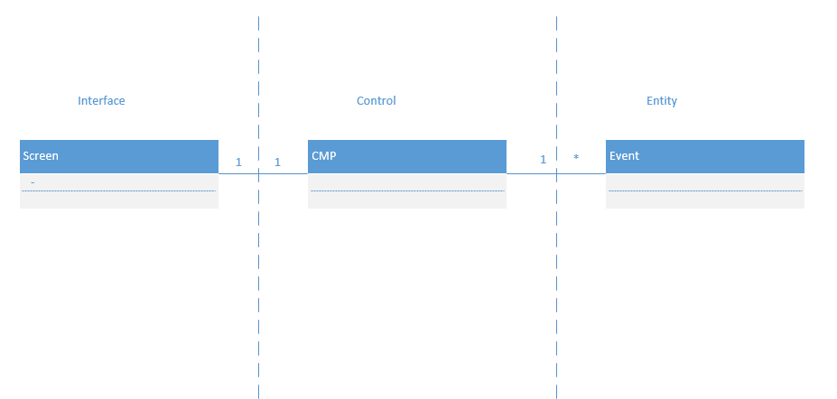

***Step 3: Draw partial detailed class diagram (add attributes to the basic class diagram)***

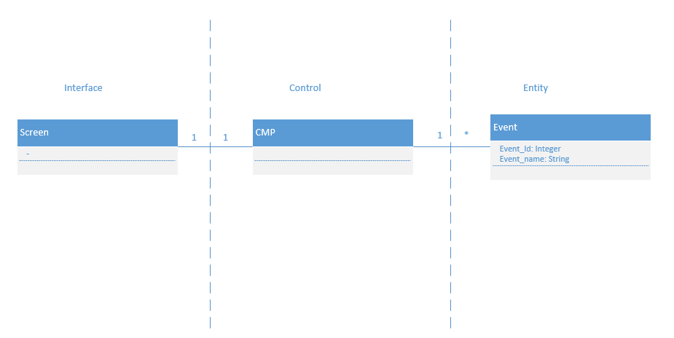

***Step 4: Verb Table (verbs can be extracted from MF of the use case specification)***

|  |  |  |
| --- | --- | --- |
| **Verbs** | **Initiator** | **Recipient** |
| Displaying (the events) | Screen | Screen |
| Selects (an event) | User | Screen |
| Displays (events details) | Screen | Screen |
| Provide (personal information) | User | Screen |
| Displays (a confirmation message) | Screen | Screen |

***Step 5: draw the sequence diagram***

